- Internship Name : Data Analysis
- Task Name: Task 10: Data Summarization Using Pandas
- Your Name : Shubhangi Naresh Khonde
- Internship Organization :
- Date:

1. Objective
To practice filtering rows, sorting data, and summarizing a dataset using the groupby() and agg() functions in Pandas.

2. Tools and Environment
- Language: Python 3
- Library: Pandas
- Environment: Jupyter Notebook in Visual Studio Code

3. Dataset Description
A sample employee dataset with 8 records and 5 columns was created using a Python dictionary and converted into a DataFrame.
Column | Description
Name | Employee name
Department | Sales, HR or IT
City | Nagpur, Pune or Mumbai
Salary | Monthly salary in rupees
Age | Employee age

The dataset was inspected using head(), shape, info() and describe() to understand its structure and data types.
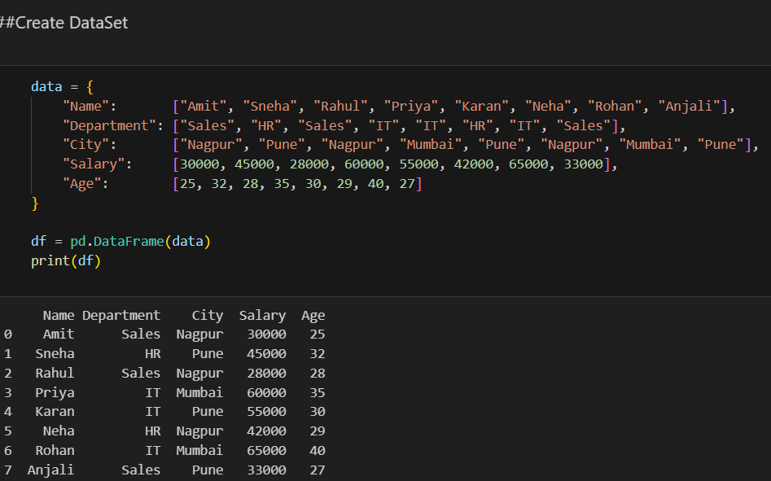

4. Methodology
4.1 Filtering Rows
Rows were selected using Boolean conditions:
- Salary greater than 40000: df[df["Salary"] > 40000]
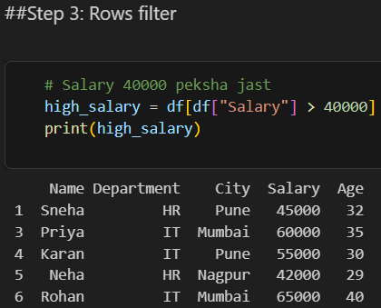

- Only the IT department: df[df["Department"] == "IT"]
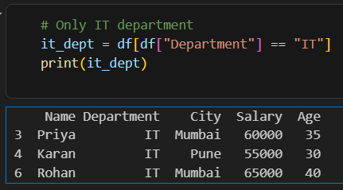

- Multiple conditions using &: df[(df["Department"] == "IT") & (df["Salary"] > 55000)]
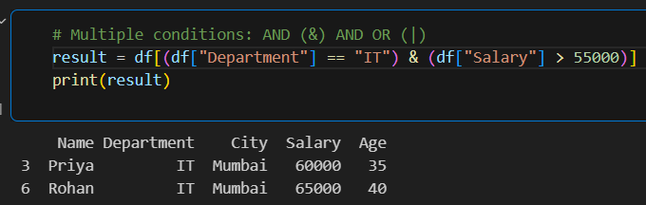

- Membership test using isin(): df[df["City"].isin(["Nagpur", "Pune"])]
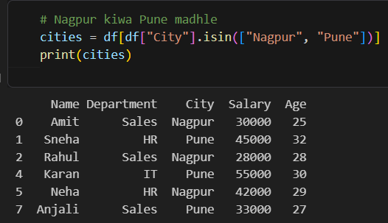

- Using query(): df.query("Age > 28 and Salary < 50000")
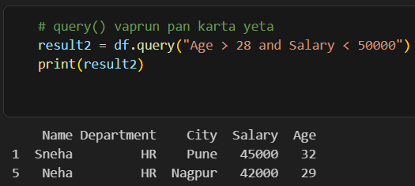

Observations:
- 5 employees earn more than 40000 (Sneha, Priya, Karan, Neha, Rohan).
- Only Priya and Rohan are in IT with a salary above 55000.
- Only Sneha and Neha satisfy both Age > 28 and Salary < 50000.

4.2 Sorting Data
The sort_values() function was used to arrange the data:
- Ascending by Salary
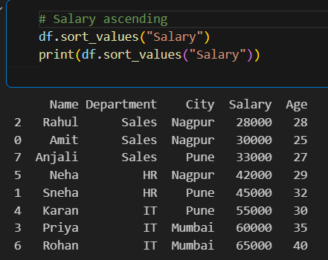

- Descending by Salary (ascending=False)
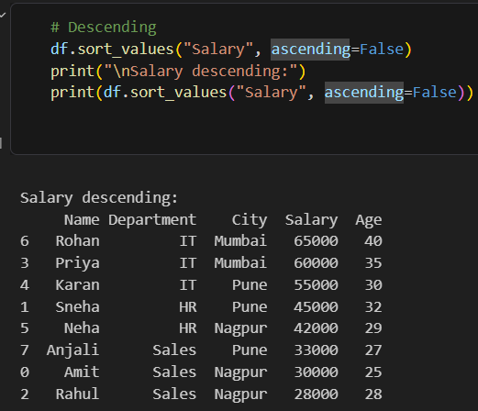

- Multiple columns: Department ascending, then Salary descending
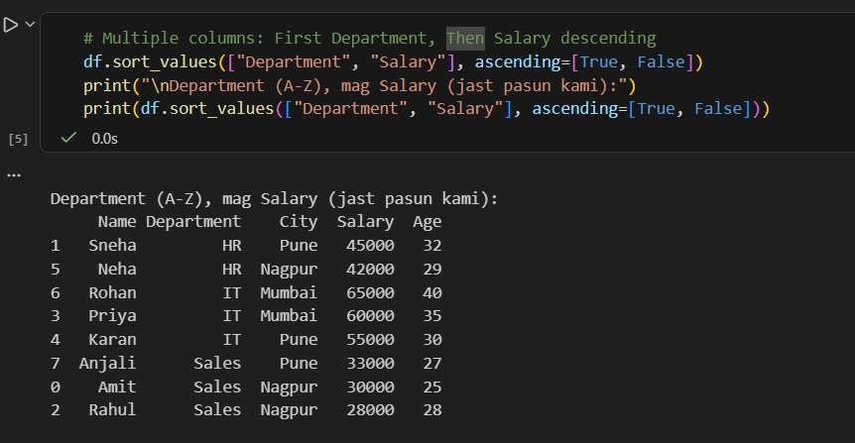

- Filtering and sorting combined (IT employees by highest salary)
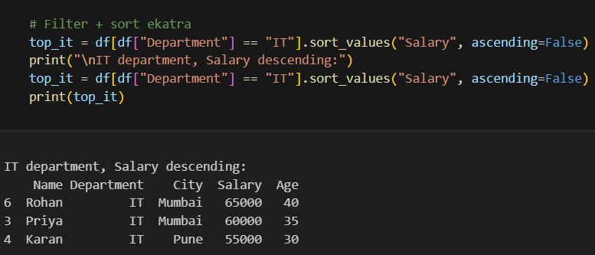
Observation: Rohan (IT, 65000) has the highest salary and Rahul (Sales, 28000) has the lowest. Sorting returns a new DataFrame and does not change the original df.

4.3 Grouping and Aggregation
The groupby() function was used with agg() to compute summary statistics per department:
python
df.groupby("Department").agg(
total_employees=("Name", "count"),
avg_salary=("Salary", "mean"),
max_salary=("Salary", "max"),
min_salary=("Salary", "min"),
total_salary=("Salary", "sum")
)

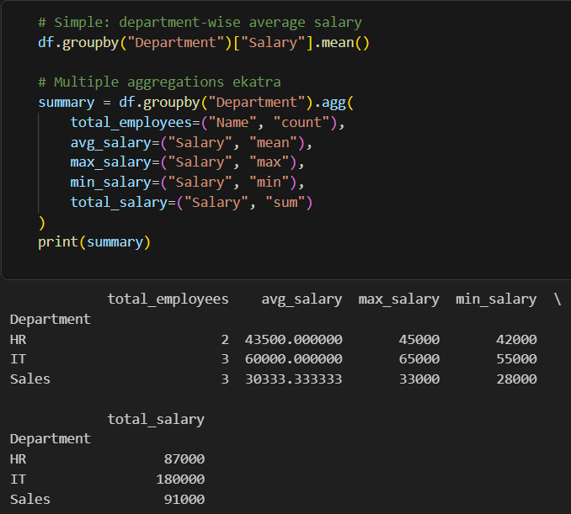

Grouping by two columns (Department and City) was also performed to get a more detailed breakdown.

4.4 Final Combined Summary
Filtering, grouping, and sorting were combined into one pipeline:
python
filtered = df[df["Age"] > 25]

summary = filtered.groupby("Department").agg(
employees=("Name", "count"),
avg_salary=("Salary", "mean"),
max_age=("Age", "max")
).reset_index()

summary = summary.sort_values("avg_salary", ascending=False)
print(summary)
Output:
Department | Employees | Avg Salary | Max Age
IT | 3 | 60000.0 | 40
HR | 2 | 43500.0 | 32
Sales | 2 | 30500.0 | 28
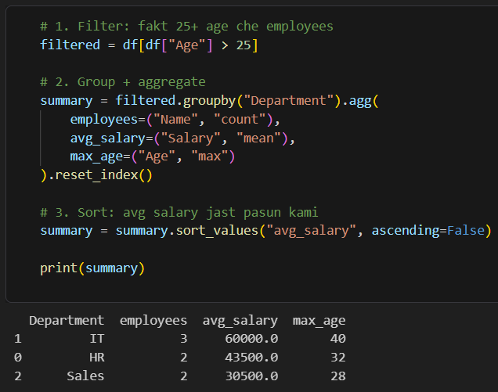

4.5 Saving the Result
The final summary was exported to a CSV file:
python
summary.to_csv("summary.csv", index=False)
The parameter index=False prevents the row index from being written as an extra column.
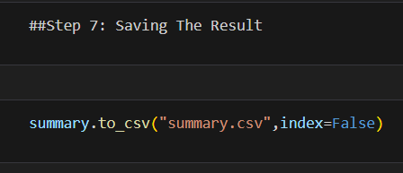

5. Key Findings
- The IT department has the highest average salary (60000) and the oldest employee (age 40).
- The Sales department has the lowest average salary (30500).
- HR sits in the middle, with an average salary of 43500.
- After removing employees aged 25 or below, Sales drops from 3 to 2 employees.

6. Conclusion
This task demonstrated how Pandas can be used to filter rows with Boolean conditions, sort data on one or more columns, and summarize data with groupby() and agg(). Combining these operations into one workflow gives a clear, sorted summary of a dataset, which was exported to summary.csv. These techniques are the foundation of real-world data analysis.

